SQL TEST
Table book
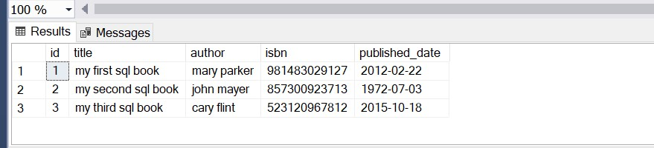
create table books1(id int primary key ,title varchar(20),author varchar(20),isbn bigint not null unique,published_date datetime)
insert into books1 values(1,'my first sql book','mary parker',981483029127,'2012-02-22 12:08:17')
insert into books1 values(2,'my second sql book','john mayer',857300923713,'1972-07-03 09:22:45')
insert into books1 values(3,'my third sql book','cary flint',523120967812,'2015-10-18 14:05:44')
select * from books1
q1)
select *
from books1
where author like '%er'
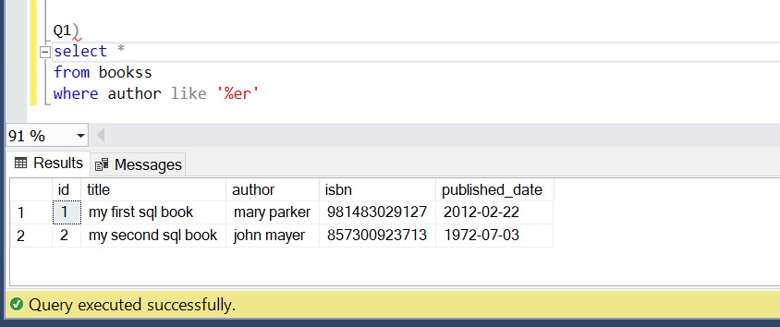

create table reviews1(id int foreign key references books1(id),book_id int,reviewer_name varchar(20),content varchar(20),rating int,published_date datetime)
insert into reviews1 values(1,1,'john smith','my first review',4,'2017-12-10 05:50:11')
insert into reviews1 values(2,2,'john smith','my second review',5,'2017-10-13 15:05:12')
insert into reviews1 values(3,2,'alice walker','another review',1,'2017-12-22 23:47:10')
select * from reviews1
q2)
SELECT title,author,reviewer_name
from books1 INNER JOIN reviews1
ON books1.id = reviews1.id;
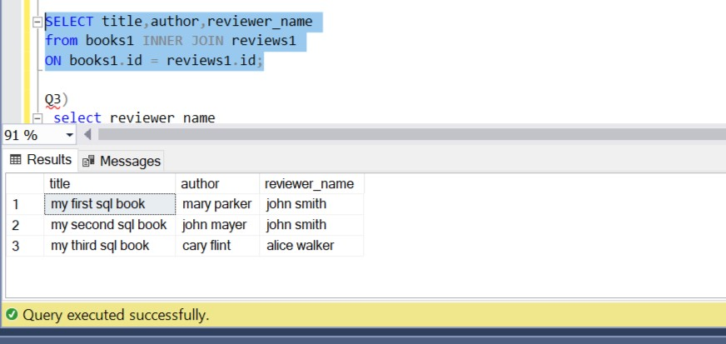

q3)select reviewer_name
from books1
inner join reviews1 on books1.id=reviews1.id
group by reviews1.reviewer_name
having count(books1.id)>1
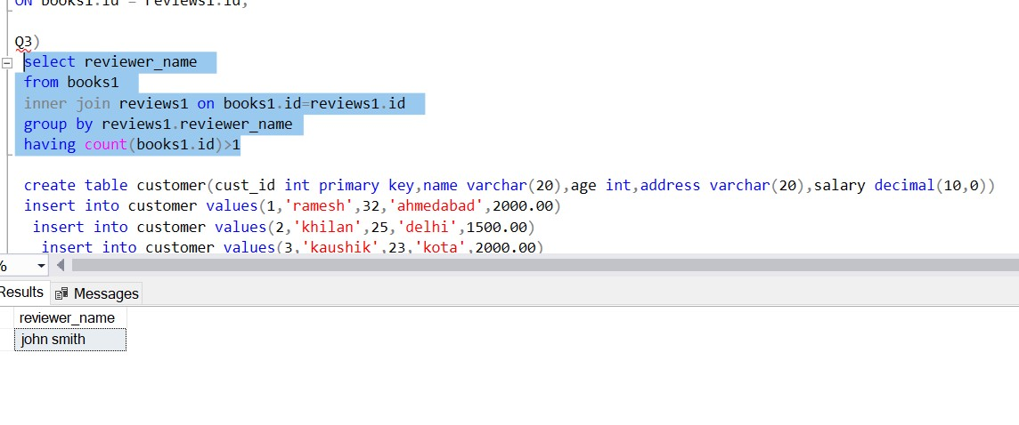

create table customer(cust_id int primary key,name varchar(20),age int,address varchar(20),salary decimal(10,0))
insert into customer values(1,'ramesh',32,'ahmedabad',2000.00)
insert into customer values(2,'khilan',25,'delhi',1500.00)
insert into customer values(3,'kaushik',23,'kota',2000.00)
insert into customer values(4,'chaitali',25,'mumbai',6500.00)
insert into customer values(5,'hardik',27,'bhopal',8500.00)
insert into customer values(6,'komal',22,'mp',4500.00)
insert into customer values(7,'muffy',24,'indore',10000.00)
select * from customer

create table orders(oid int primary key,datetiming datetime,cust_id int foreign key references customer(cust_id),amount bigint)
insert into orders values(104,'2009-10-08 00:00:00',3,3000)
insert into orders values(100,'2009-10-08 00:00:00',3,1500)
insert into orders values(101,'2009-11-20 00:00:00',2,1560)
insert into orders values(103,'2008-05-20 00:00:00',4,2060)

select * from orders
q4)
select address
from customer as c inner join orders as o on c.cust_id=o.cust_id
where c.address like '%o%'

q5)select datetiming, count( cust_id) as total_customers
from orders
group by datetiming
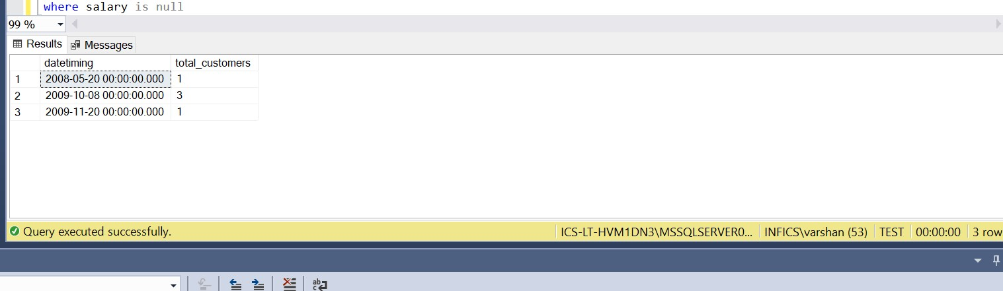

create table employee(id int primary key,name varchar(20),age int,address varchar(20),salary decimal(10,0))
insert into employee values(1,'ramesh',32,'ahmedabad',2000.00)
insert into employee values(2,'khilan',25,'delhi',1500.00)
insert into employee values(3,'kaushik',23,'kota',2000.00)
insert into employee values(4,'chaitali',25,'mumbai',6500.00)
insert into employee values(5,'hardik',27,'bhopal',8500.00)
insert into customer values(7,'komal',22,'mp',null)
insert into customer values(8,'muffy',24,'indore',null)
select * from employee

q6)select name
from employee
where salary is null

q7)
select gender ,count(*) as total
from studentdetail
group by gender

